Jira Lab Assignment 4

Harsh Rakeshkumar Bhatt

Project Management, Conestoga College

MGMT8750: Agile Project Management

Professor Shams Salim

June 13, 2023

Screenshot 1
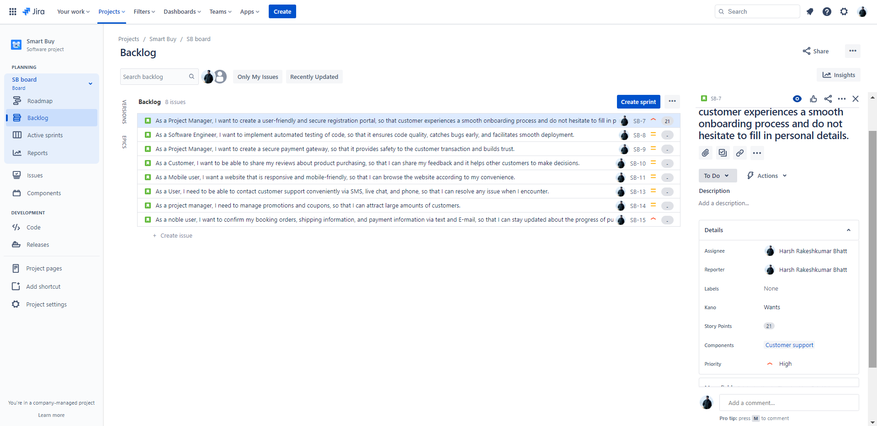

Screenshot 2

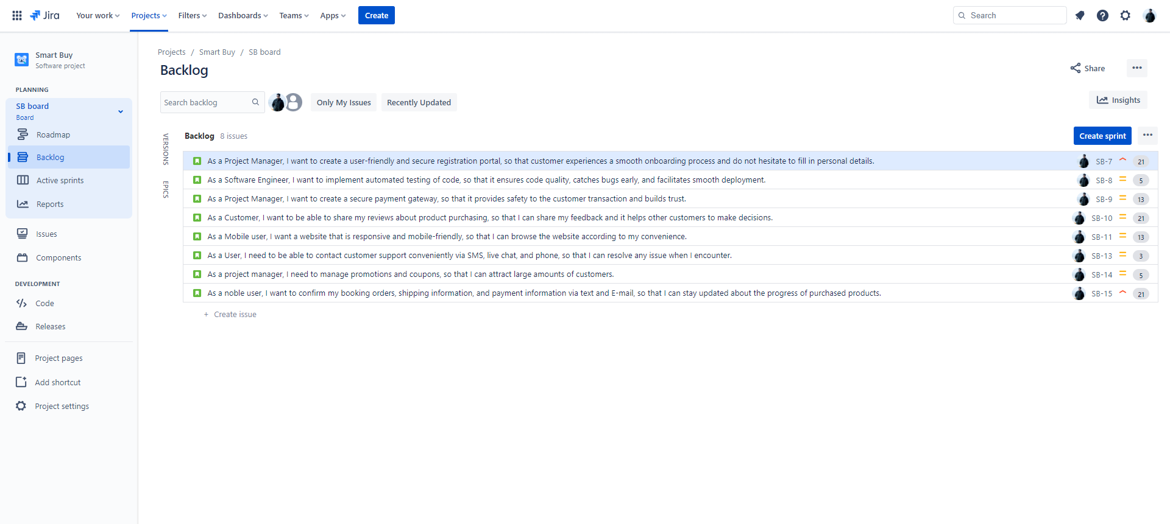

Screenshot 3
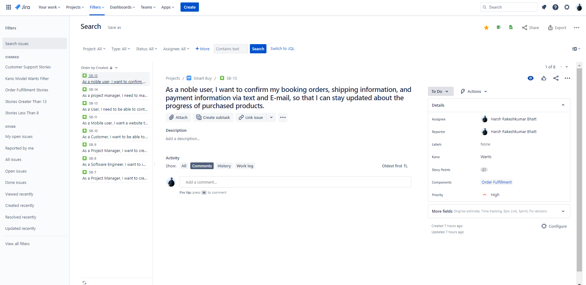

Screenshot 4
